Question 1 (15 marks)

Your company has recently revamped its health care insurance plan. You now have a choice of one of three plans as shown below:

Plan 1: The monthly cost is $32 and the insurer pays 90% of all expenses after you have paid the first $500 each year ($500 deductible).
Plan 2: The monthly cost is $5 and the insurer pays 90% of all expenses after you have paid the first $1200 each year ($1200 deductible).
Plan 3: The monthly cost is $24 and the insurer pays 70% of all expenses (no deductible).

You have gone back several years and examined past medical expenses and created the following probability distribution.

Annual Medical Expenses ($) | Probability
100 | 0.15
500 | 0.30
1500 | 0.35
5000 | 0.15
10000 | 0.05

Required:
- Determine which plan you should select.
- Calculate the expected annual cost resulting from your choice.

Question 2 (15 marks)

Simon Lafleur is the founder and sole proprietor of Wetaskawin Wildcatters (WW). WW develops oil wells in unproven territory. Simon has poured his life savings into WW in the hope of finding a major well.

WW has purchased drilling rights on a number of tracts that have been spurned by the major oil companies. Simon has just received a report from his consulting geologist that one of these tracts looks modestly promising.

The geologist has stated that based on his experience there is a one in four chance of finding a small oil reservoir on the site. Drilling for oil will cost $100,000 and if oil is not found this entire investment will be lost. Since WW has little capital left, this loss could spell doom for the company.

If oil is found there it would likely be enough to generate revenues of $800,000. (Ignore time value of money considerations – assume that the $800,000 can be compared directly to the cost of drilling, so that a net gain of $700,000 would be realized if he found oil.) Simon is confident that this amount of money would give him the breathing space required to find the really big “gusher”.

Shortly after receiving the report from the geologist, Simon was offered $90,000 for the drilling and extraction rights from one of the major oil companies. This would provide a good infusion of cash without the risk of losing $100,000 if he decides to drill.

- Use a decision tree to model Simon’s decision (Treeplan software is optional). Assuming that Simon bases his decisions on EMV, what should he do?
- What is the expected value of perfect information?

Question 3 (10 marks)

Refer to Question 1 above. In discussing the decision with the geologist, Simon has learned that a confidential seismic test could be conducted on the site at a cost of $30,000. The geologist estimates that, allowing for ‘false positives’, there is a 0.3 chance of getting a favourable test result in which case the probability of finding oil would be 0.5. On the other hand, an unfavourable result would indicate that the chance of finding oil is only 0.143.
- Revise your decision tree to model this revised decision. Again assuming that Simon will base his decision on EMV, what should he do?

Question 4 (20 marks)
Ed owns a small business called Kingston Anchors, which produces four types of anchor for pleasure craft:
Danforth: a lightweight, temporary anchor;
Small Plow: an all purpose anchor for boats less than 24';
Large Plow: same thing for boats longer than 24';
Hereshoff: a fancy, show-off anchor for larger boats.
Each anchor requires metal to be cut, ground, tumbled and finally welded and assembled. Because of earlier foresight, Ed has stockpiled plenty of raw material in the form of steel bars, sheets, and tubes. The production data for each anchor of each type in the next cycle is as follows:

Cutting
Grinding
Tumbling
Weld/Assy
Maximum
Contribution
Anchor Type
Time
Time
Time
Time
Demand
to Profit
Danforth
5 min.
8 min.
2 min.
4 min.
800
$50
Small plow
10 "
20 "
5 "
6 "
300
110
Large Plow
15 "
20 "
7.5 "
8 "
200
130
Herreshoff
30 "
20 "
10 "
10 "
100
200
Hours Available
120
240
100
80
Ed needs to know how many of each type of anchor he should plan to produce in order to maximize his contribution to profit. We will define D, SP, LP and H to be the number of Danforths, small plows, large plows and Herreshoffs that Ed decides to produce. Converting all the production times to minutes, the complete formulation will be as follows:

MAXIMIZE
Subject to:

We must also constrain the number of each type of anchor to be non- negative.

We can enter this formulation into Excel using trial values for the decisions, the number of anchors of each type to be produced. (Using a trial value of 1 lets you quickly ensure that your formulas are correct; that is, that the value of the left hand side, or LHS, of each inequality is correct.) The constraint limits, or Right Hand Sides (RHS) are entered as numbers. The model is shown below.

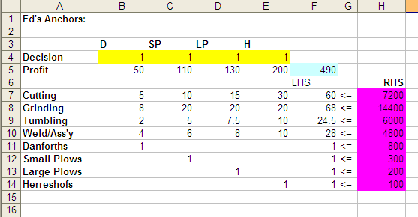

After calling up the Solver and solving the problem the sheet appears:

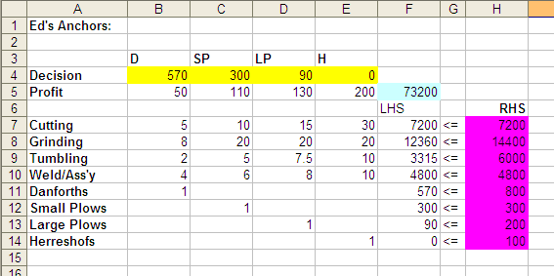

The answer and sensitivity reports are as follows:

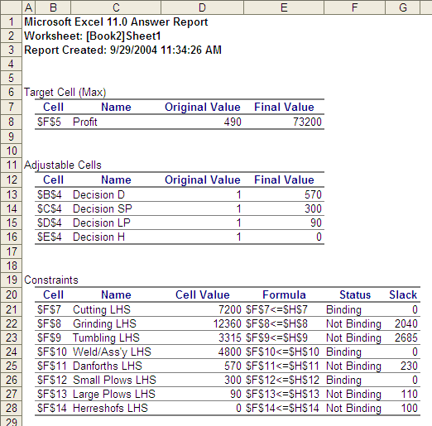

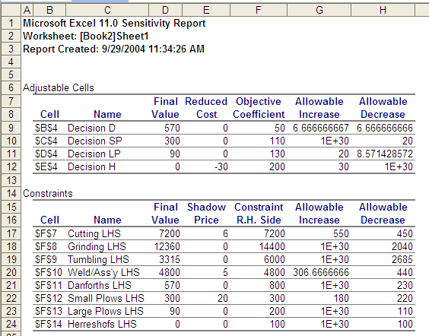

a) Ed notices that your plan does not call for any Hereshoffs to be produced. He then says that he has promised 2 of these to special customers. What can you tell Ed about the cost of his promise? (3 marks)
b) The strong demand for Danforths has led Ed to think of raising the price, which would result in a $6 increase per anchor in contribution. Ed has evidence that such a small increase in price will not affect the demand for Danforths. What will be the effect on the optimal solution of such a change? (Note: Don’t re-solve the problem. Use your output from a) to indicate what you can say about Ed’s change in price.) (3 marks)
c) Ed has the chance to hire some part-time welding support from another business, but it is expensive. The "standard" welding hour charge which he used to compute the contribution margins was $25/hr, but he will have to pay $75/hr to buy additional welding support. How many hours should Ed buy at this price? (Note that the units of measurement in the solution are minutes that must be converted to hours to complete this part of the question.) (3 marks)
d) Ed's son has agreed to help out by grinding for 30 hours. How will Ed's plan change by having more grinding hours available? (3 marks)
e) Recent competition in the small plow end of the market is causing Ed to consider cutting back on the price, and hence the profit contribution of this anchor type. How far can the contribution margin be cut before the production plan will change? (3 marks)
f) Suppose the metal cutter breaks down and 8 hours of cutting time are lost. Without resolving, what can you say about the effect on profit contribution? (5 marks)

Question 5 (15 marks)

Linear programming models are used by many Wall Street and Bay Street firms to select a desirable bond portfolio for their clients. The following is a simplified version of such a model. TAL Private Investments has $1 million to invest for a client and is considering an investment in four bonds. The expected annual return, the worst-case annual return and the duration of each bond are given below. (The duration of a bond is a measure of its sensitivity to interest rate changes.)

 | Expected  return | Worst-case  return | Duration
Bond 1 | 13% | 6% | 3
Bond 2 | 8% | 8% | 4
Bond 3 | 12% | 10% | 7
Bond 4 | 14% | 9% | 9

TAL wants to maximize the expected return from the investment subject to three constraints that have been placed on it by the client.
- The worst-case annual return of the portfolio should be at least 8%
- The average duration of the portfolio must be no more than 6. (For example, a portfolio that was made up of $600,000 in Bond 1 and $400,000 in Bond 4 has an average duration of It may also help you to recognize that can be rewritten as or .)
- At most, 40% of the portfolio can be in invested in a single bond.

- Formulate a linear model that will help TAL make the portfolio composition decision. Be sure to define your decision variables clearly including the units of each. (9 marks)
- Solve the problem using Excel and Solver and submit a printout of your model as is done in Question 1 above. (6 marks)

